**Lab #5 – Cloudera on Google Cloud**

Some students were not able to successfully download and configure Cloudera on VirtualBox due to various computer capacity issues. You can follow this guide as an alternative solution for Cloudera on VirtualBox (Lab #3 and Lab #4). If your VM performs poorly and runs very slow, you can also follow this guide.

**Step 1: Sign in Google Cloud with Gmail and create a new project.**

Go to <https://cloud.google.com/>

Log in with your Gmail account, you will have to link one of your bank cards to receive $300 free credit to use in one year. (I used my Fordham email here)

After login, fill out all information if asked, go to Console.

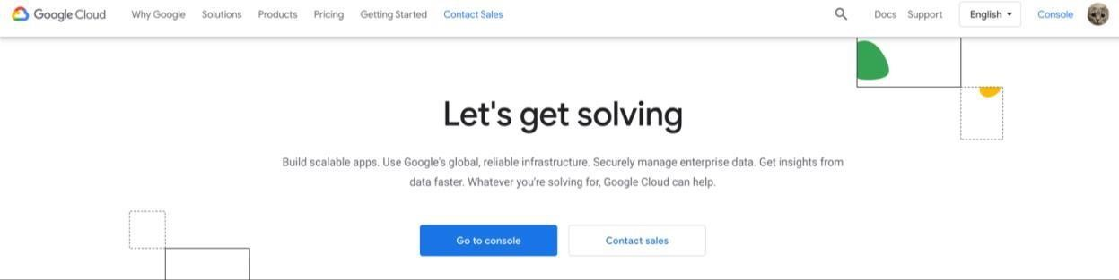

Then, you will see the main menu bar on the left side of the dashboard.

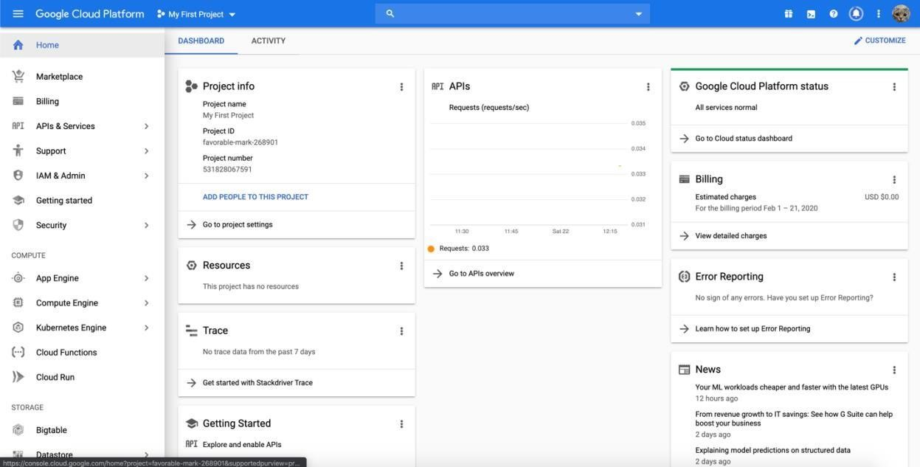

Click the down arrow to create a new project.

The dashboard of your new project.

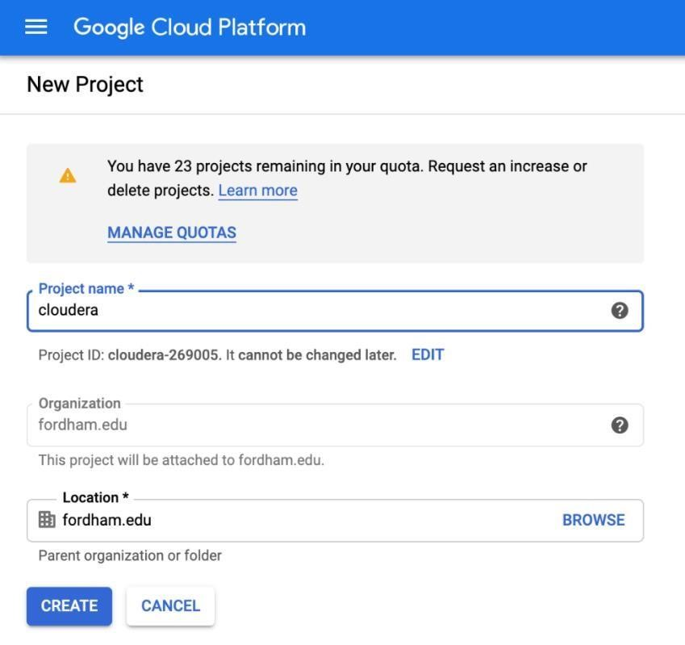

**Give your project a name.**



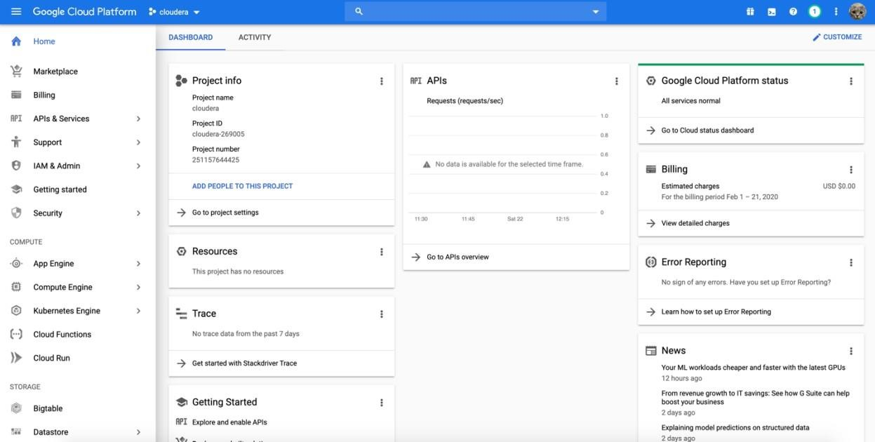

**Congrats! You have created your new project!**

**Step 2: Create VM instances on in your project.**



Under the



menu bar find Compute Engine.

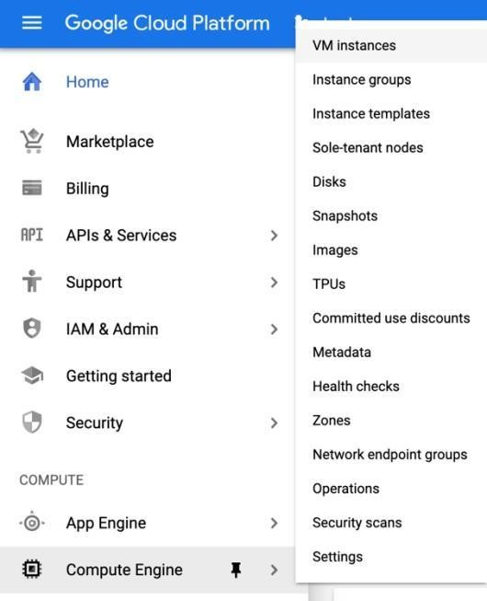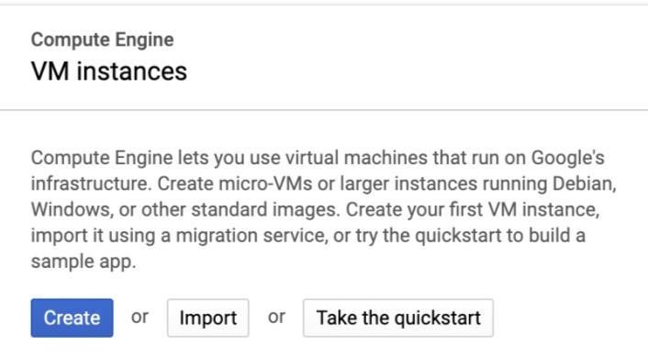

**Then, follow the below step 1~10 carefully and configure the instances exactly as the picture shown.**

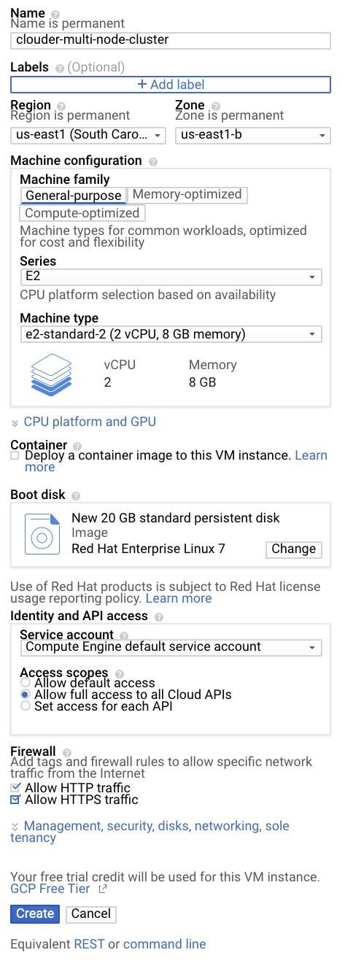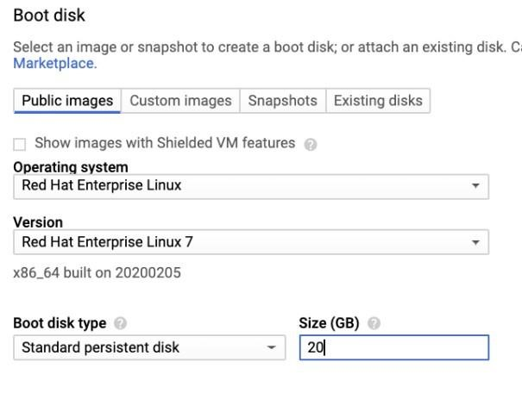

**Step 1:**



**Give it name.**



**Step 2**



**Step 3**



**Step 4**



**Step 5**



**Step 6**



**Step 7**



**Step 8**



**Step 9**



**Step 10**



30

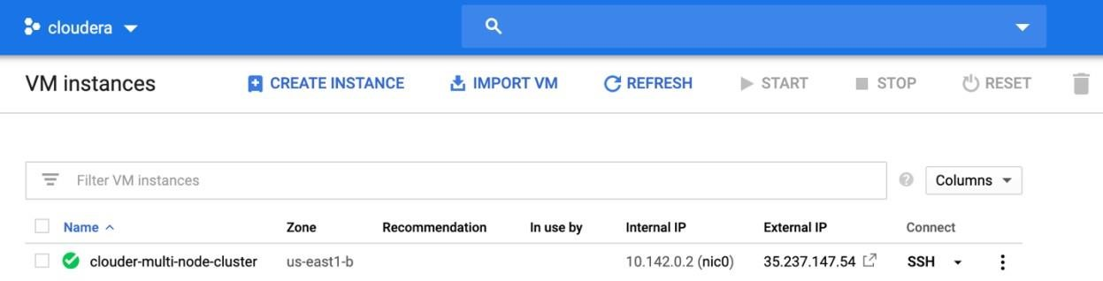

Click on **Create instance**, and **repeat** the above 10 steps to create 3 more instances, in **step 1 name them node1, node2, node3**. All other steps are exactly the same.

After you done that, you should see all instances.

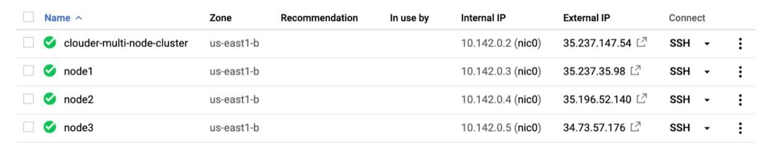

Connect to **all 4 instances** using the built-in browser window.

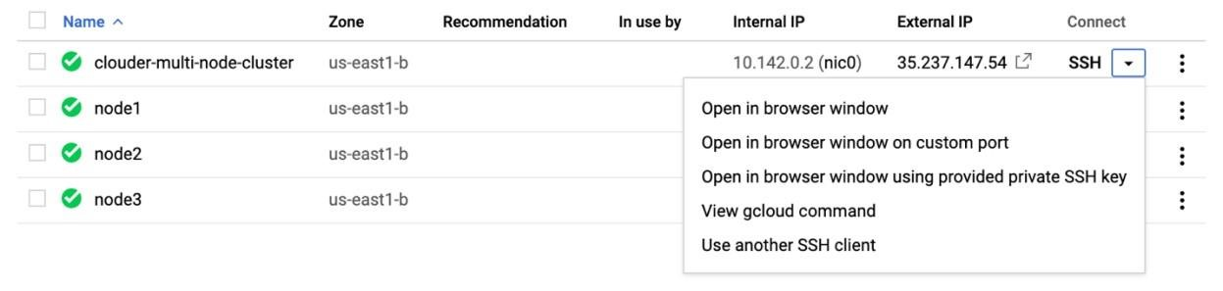

The pop-up window looks like this for all 4 instances (you should have 4 windows running, one instance each).

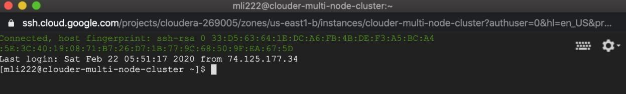

Run the following commands!

**configure**

**3:**

**file.**

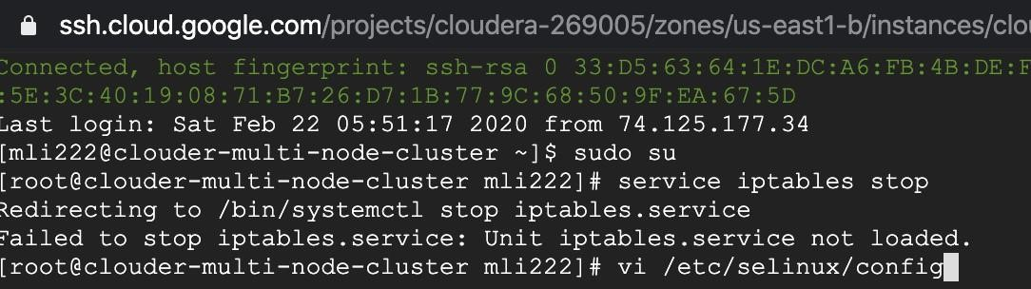

**switch to root user**



**1:**



**2**



**:**



**stop firewall**



Remember to press “I” key to change to insert mode to edit the file.

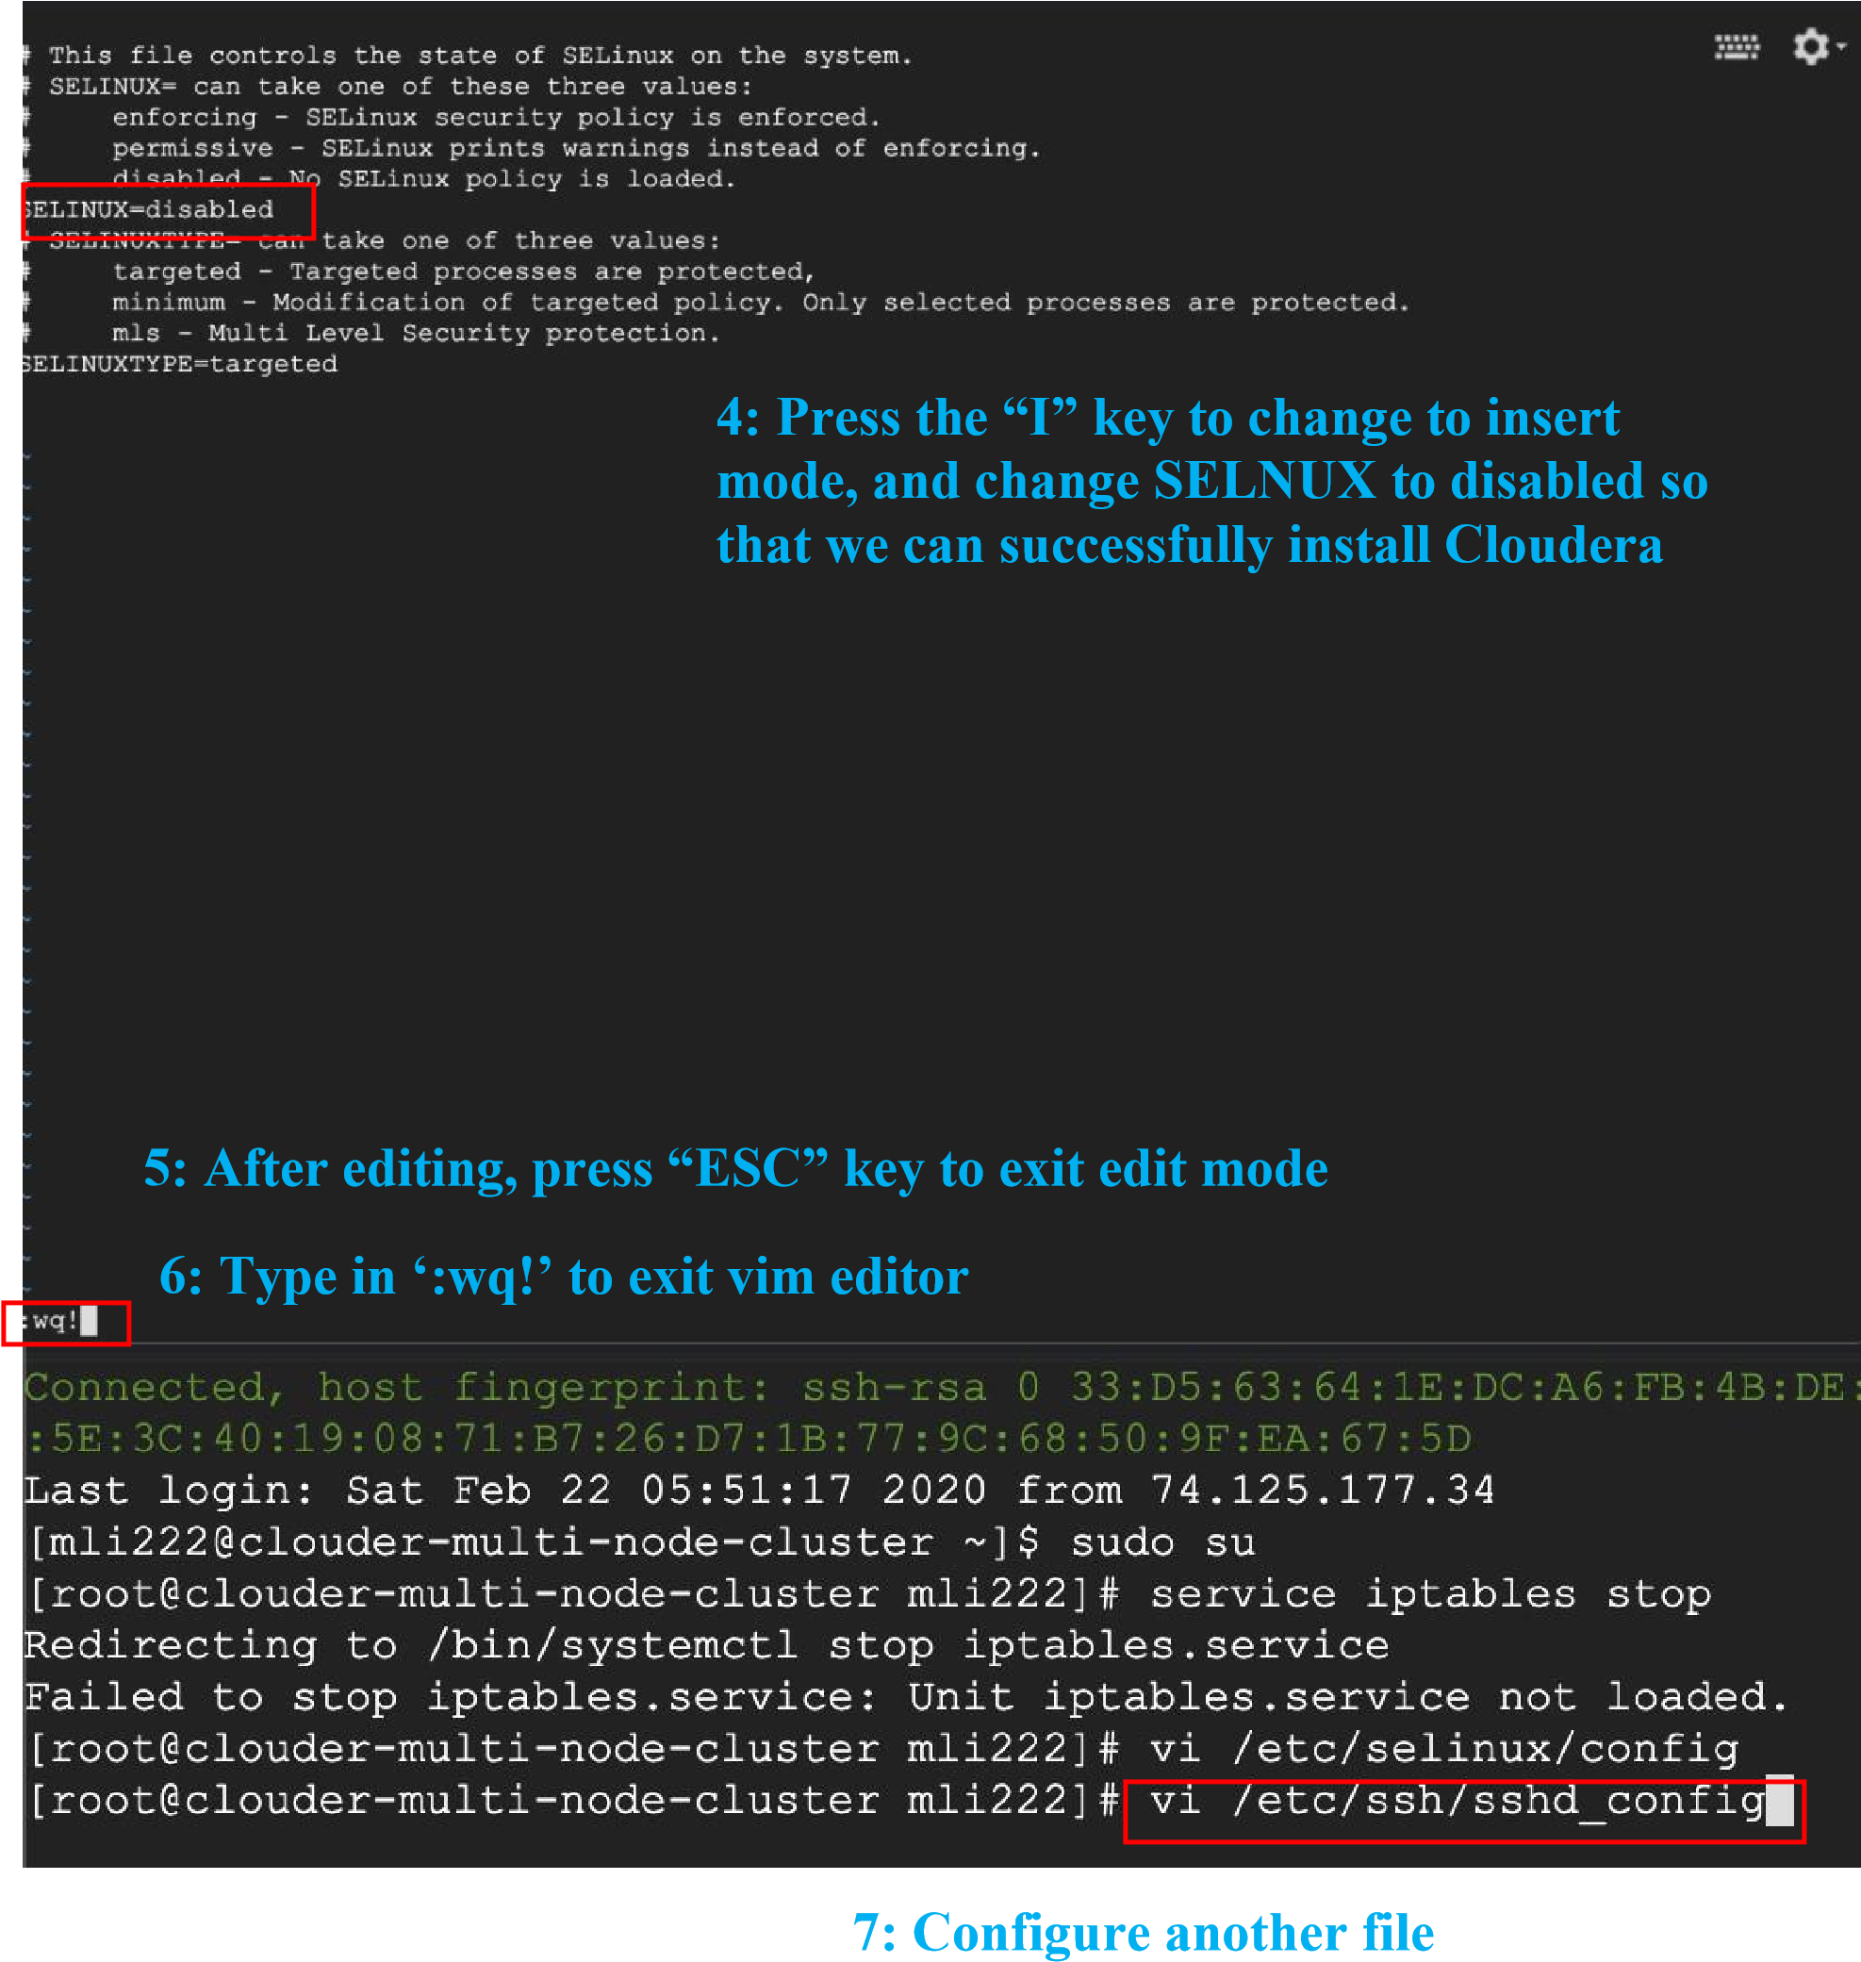

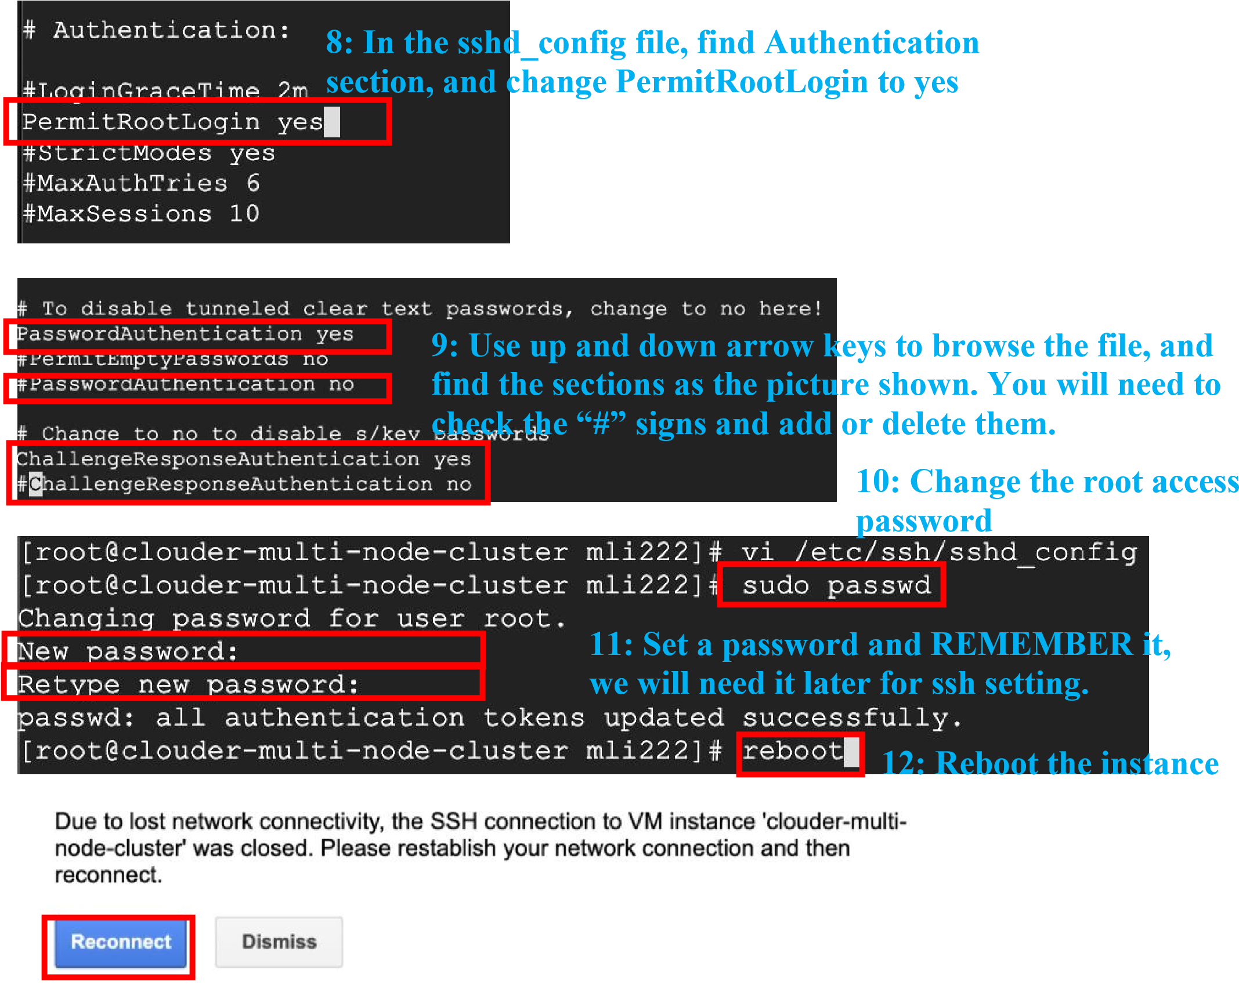

**Repeat the above steps for all 4 instances,** make sure you use the same password for all instances.

After you configured all 4 instances, go back to the window for the **cloudera-multinodecluster** which is the instance we will download Cloudera installer on. Run the following commands to download.

1. Switch to root user.

**sudo su**

1. Check if Selinux is disabled.

**sestatus**

1. Install yum. **yum install wget**

1. Download the package.

**wget http://archive.cloudera.com/cm7/7.1.4/cloudera-manager-installer.bin**

1. Make the file accessible.

**chmod +x cloudera-manager-installer.bin**

1. Open the installer.

**./cloudera-manager-installer.bin**

You should see something like this. Use arrow keys and return keys to navigate. Accept all license.

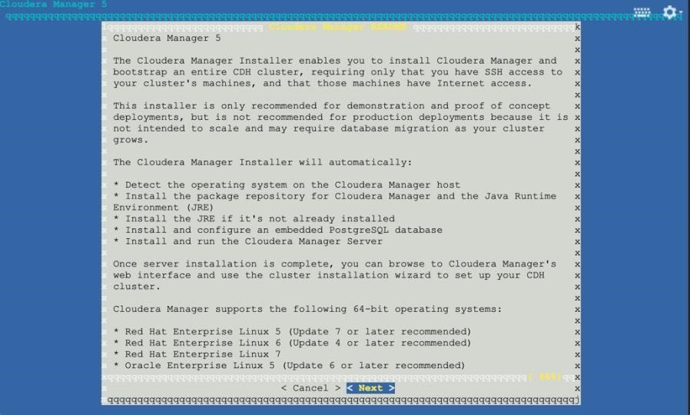

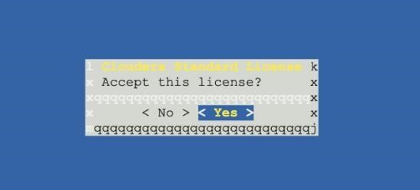

This step will take a few minutes.

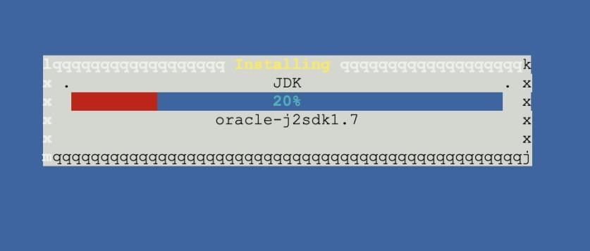

Press enter to finish the installation process.

**Step 3: Firewall Settings**

Follow the steps to add two firewall rules for us to open Cloudera Manager and HUE UIs.

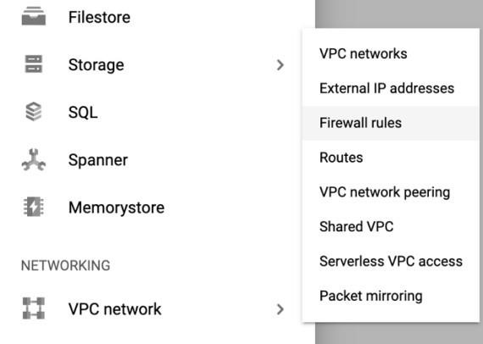

**Make sure you set everything exactly as the picture shown below.**

**There are two pictures:**

**One for port: 7180 (Cloudera Manager)**

**Second for port: 8888 (HUE)**

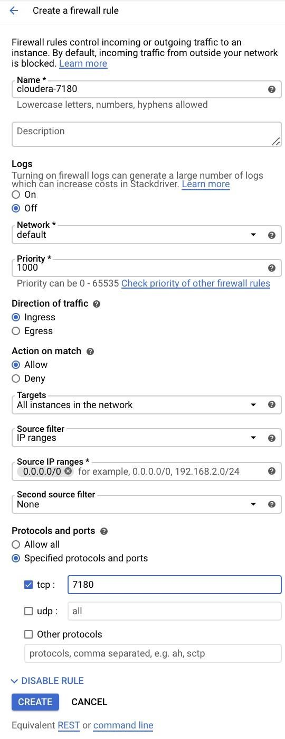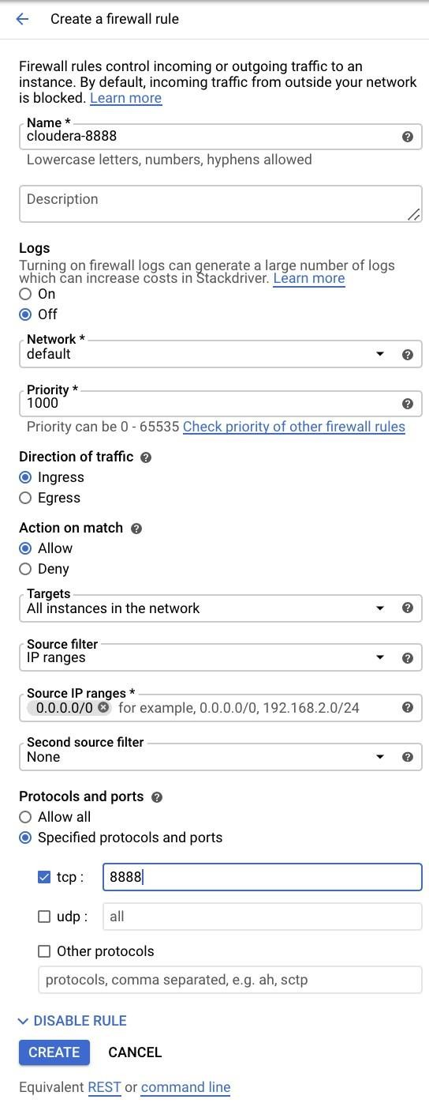

After you create two firewall rules, you should see them.



**Step 4: Open up browsers and go to web UIs**



Go back to VM instances.



Copy the External IP for the clouder



-



multi



-



node



-



cluster.

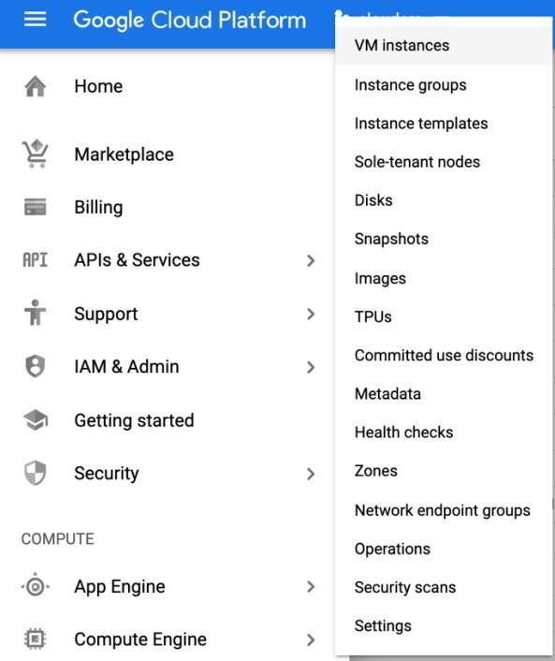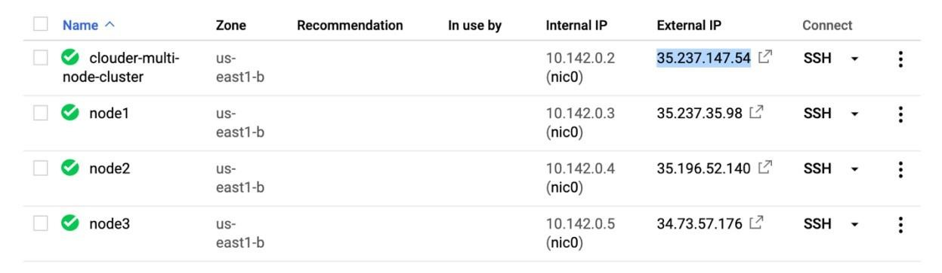

Paste it in our web browser and add 7180.

Something like 35.237.147.54:7180

Note: Your IP address should be different than mine.



You should see the login page.

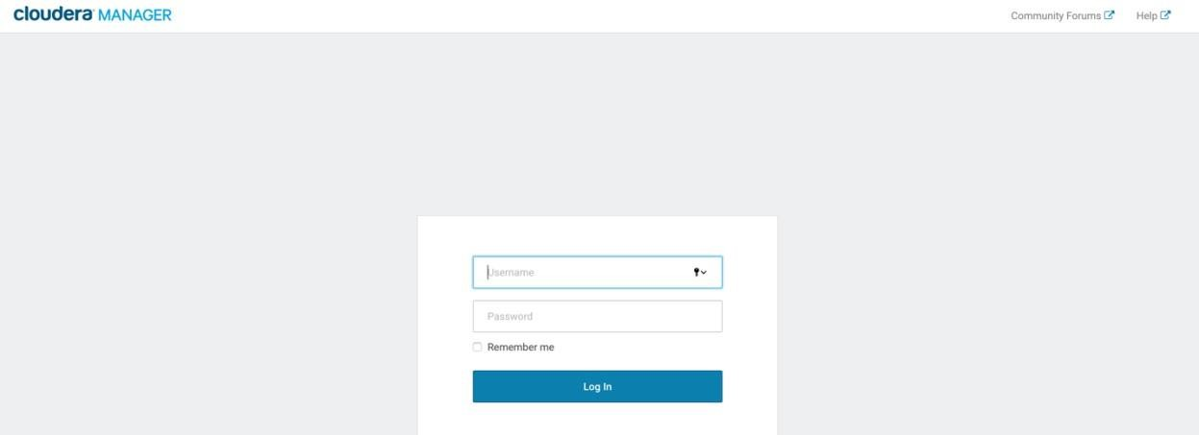

**Username: admin**

**Password: admin**

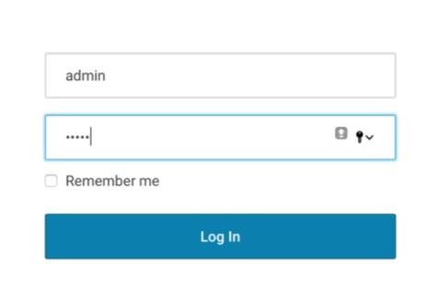

Use free trial for now



and click on Continue.

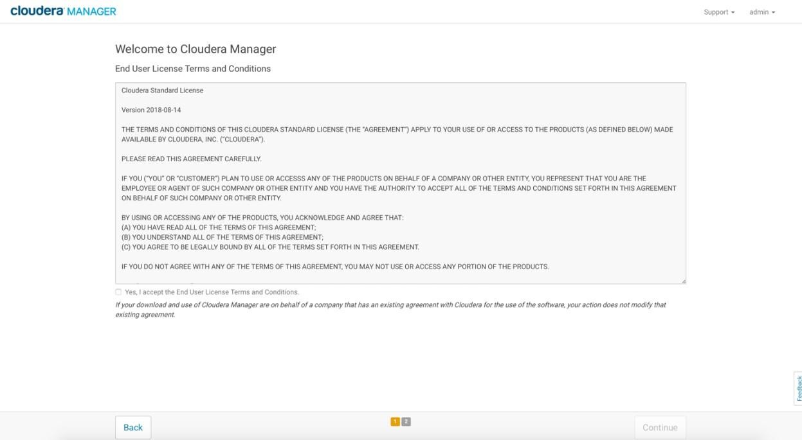

You will see

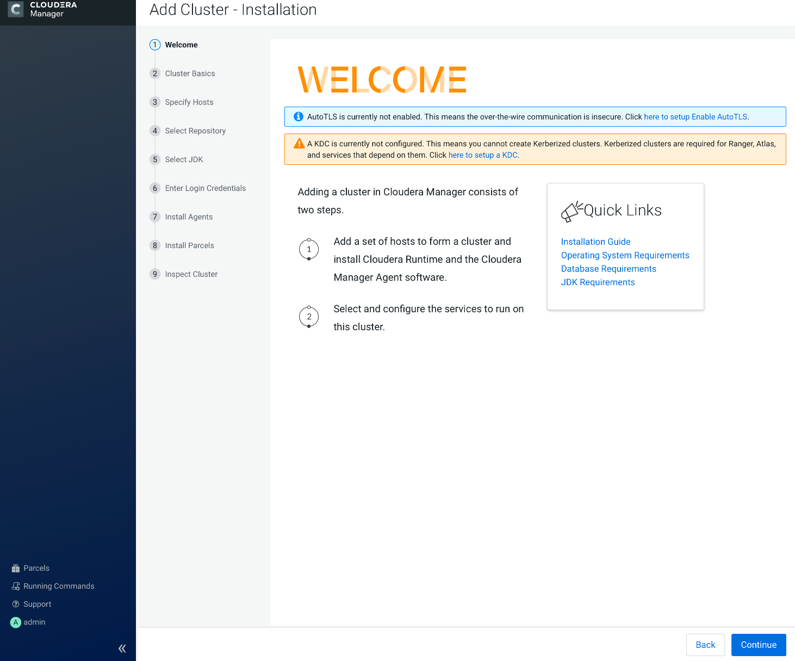

Name your Cluster and continue

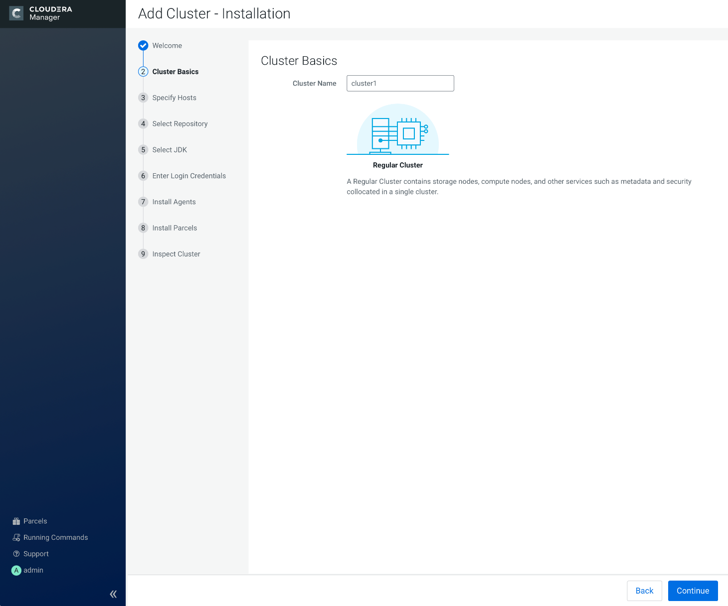

Here, type in the names of your 4 instances and click on search.

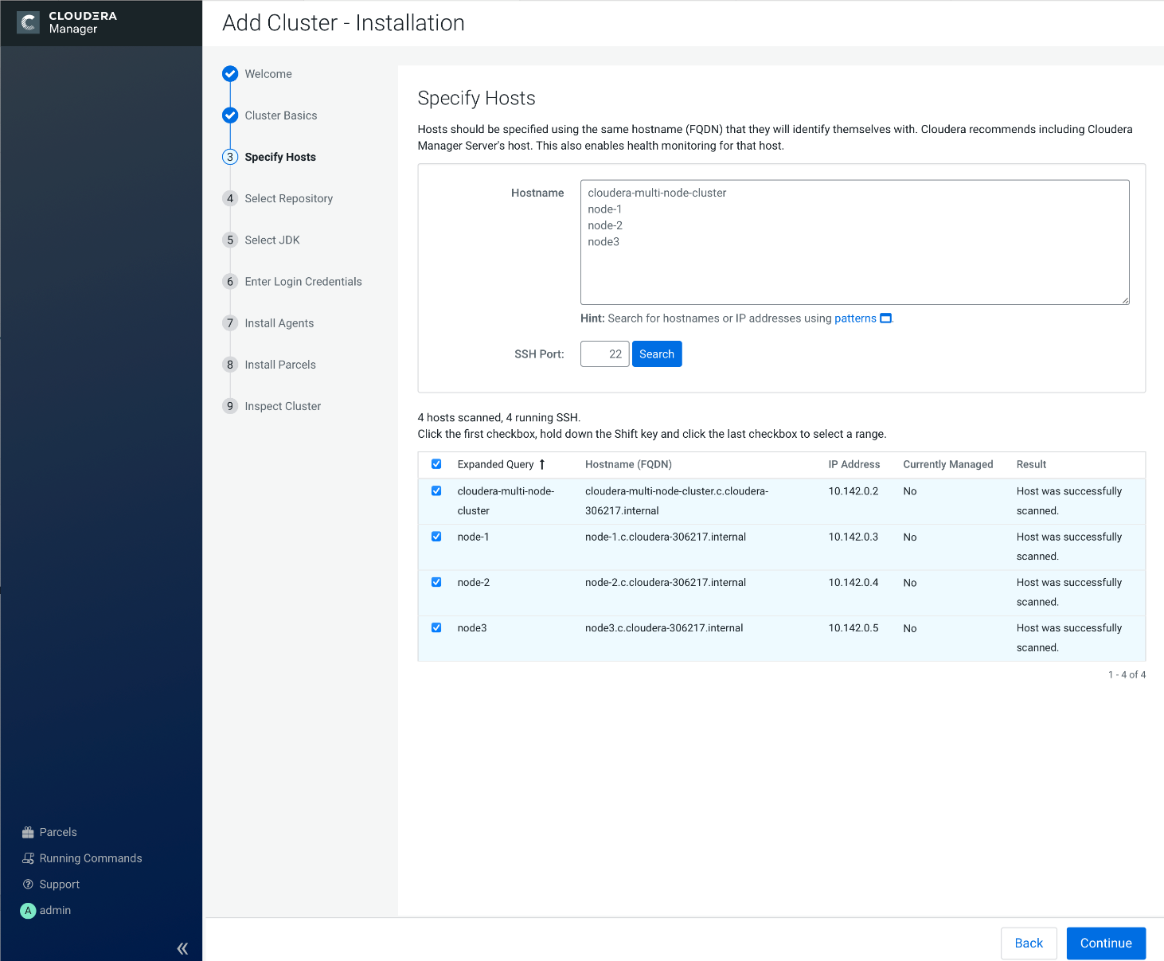

Keep the default settings.

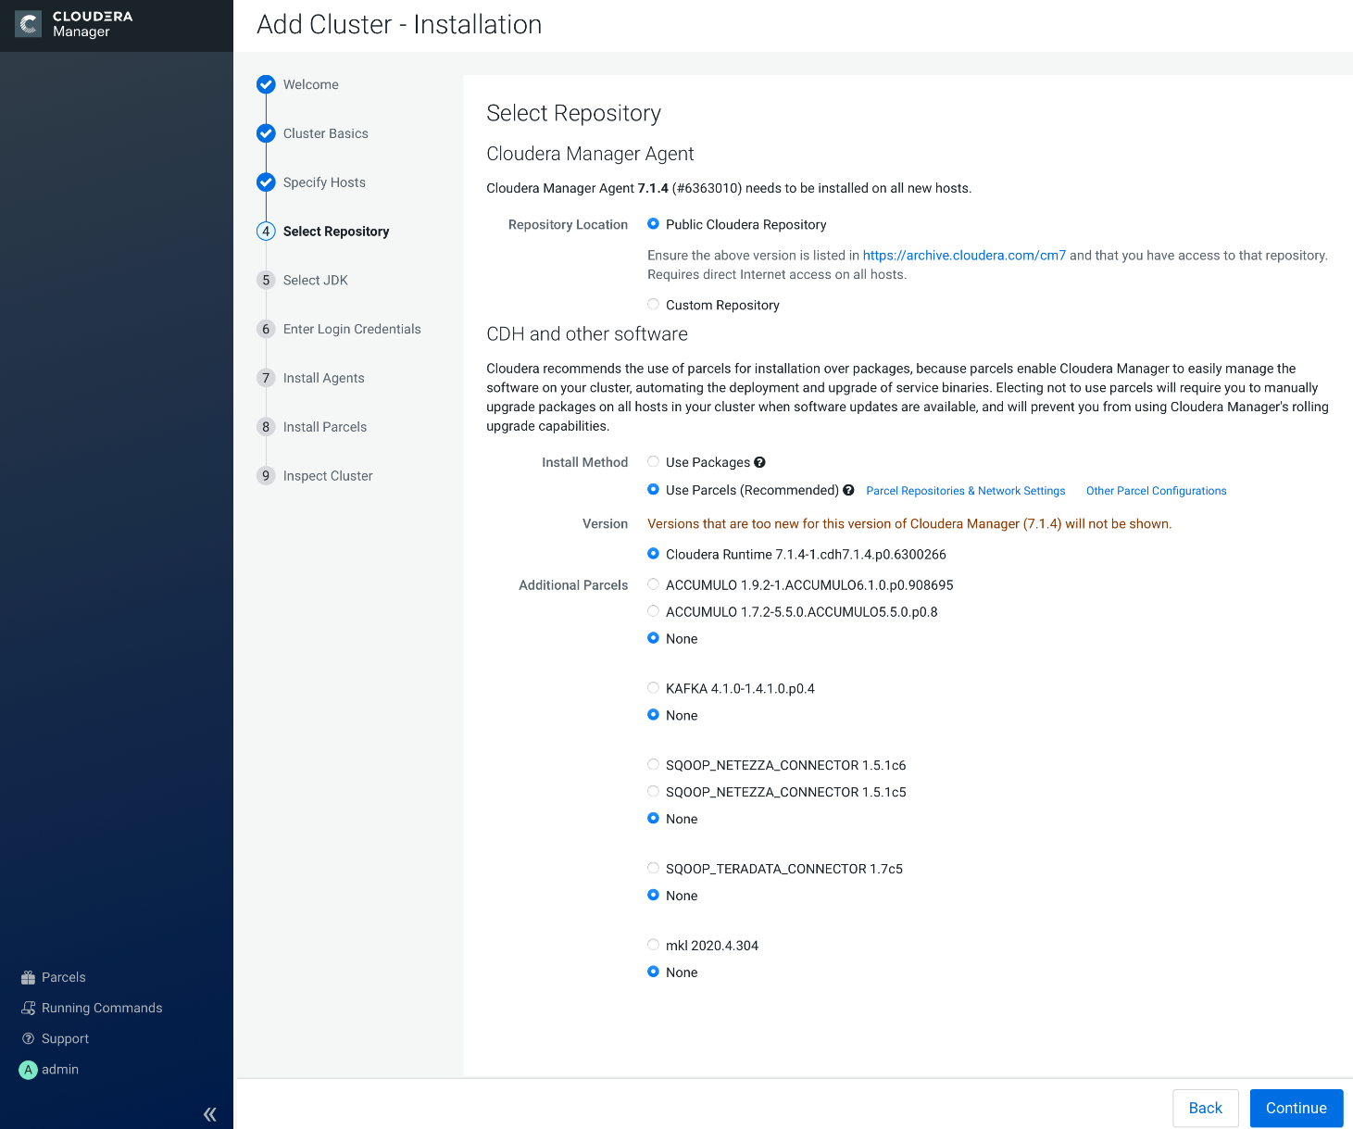

Install a Cloudera-provided version of OpenJDK

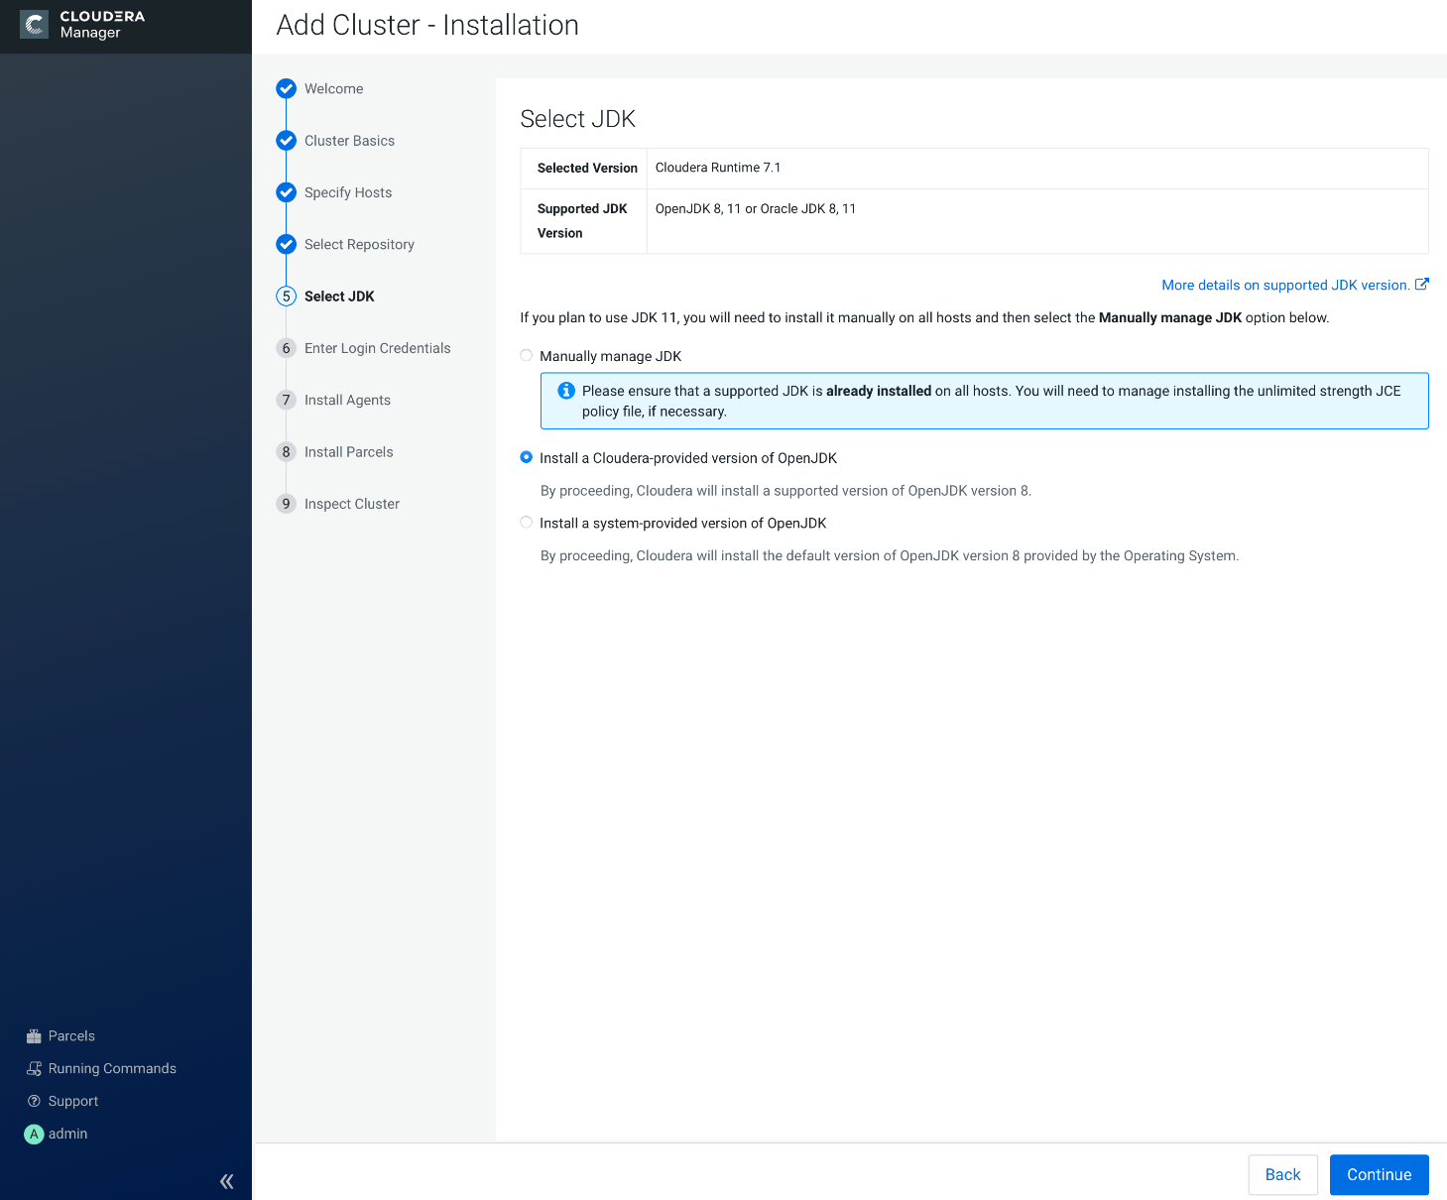

Set password and continue

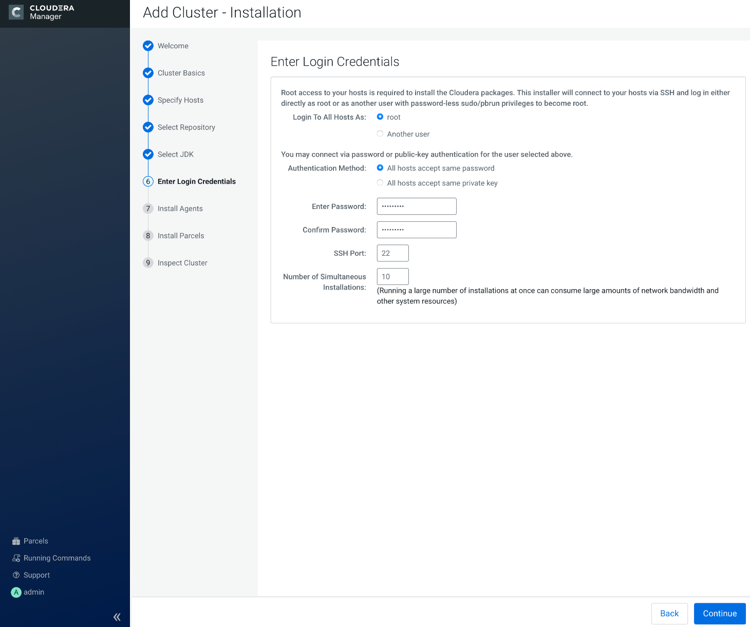

Wait for a few minutes…

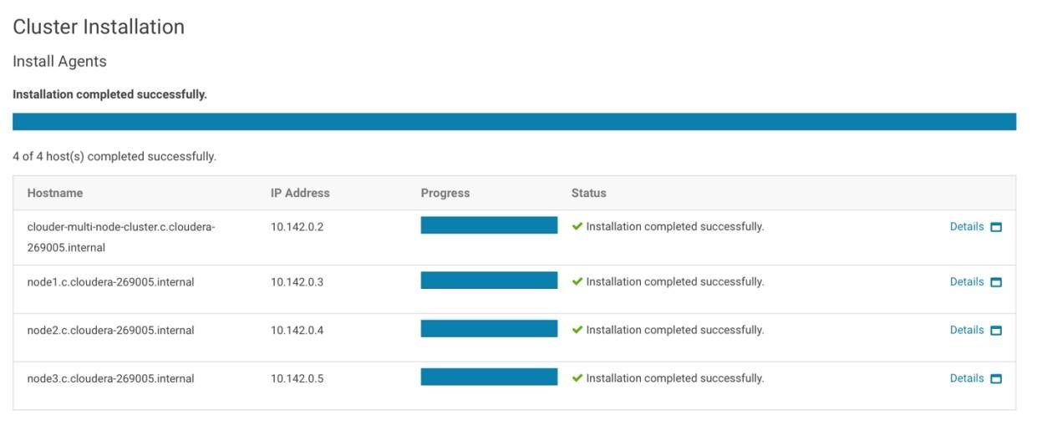

Click on Continue and wait for another few minutes…

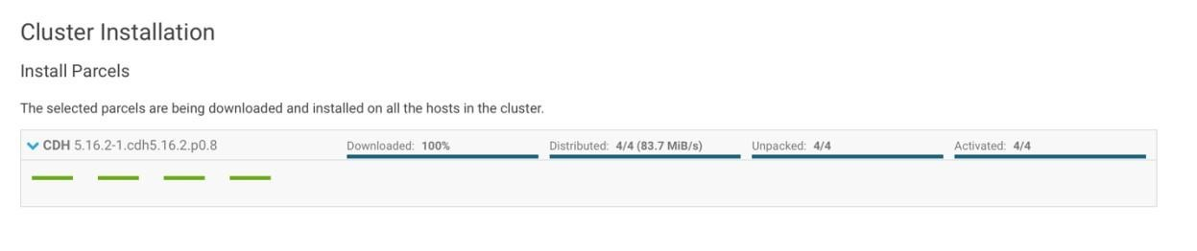

Let it check all hosts…

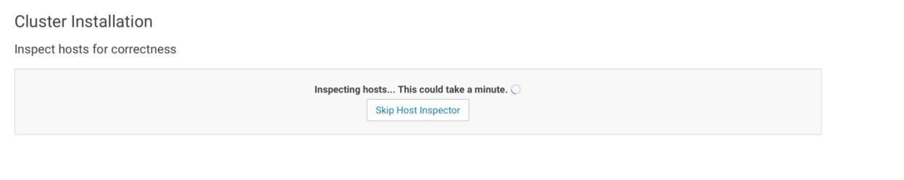

And click on Finish once it finishes.

**Note**: you may see one or two warnings highlighted in yellow box. It is okay, so just ignore and click on finish.

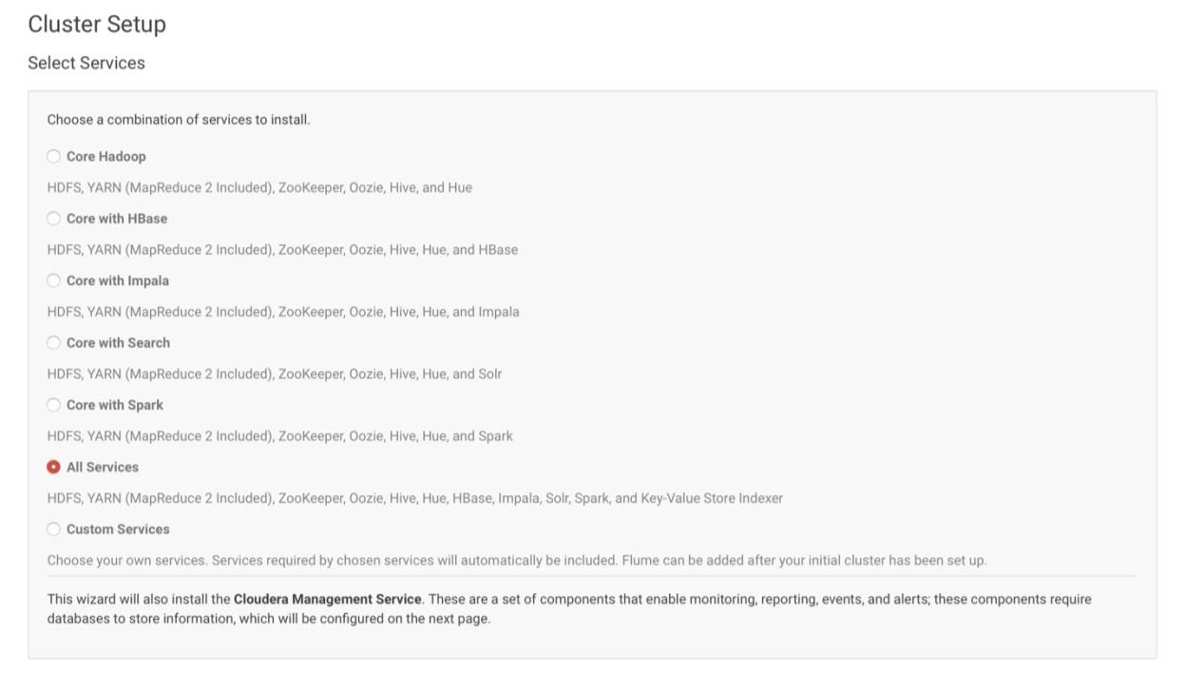

Keep default settings and click on Continue.

**Note**: you default setting may be different than mine. You do not have to change yours, just keep the default settings and continue with the installation.

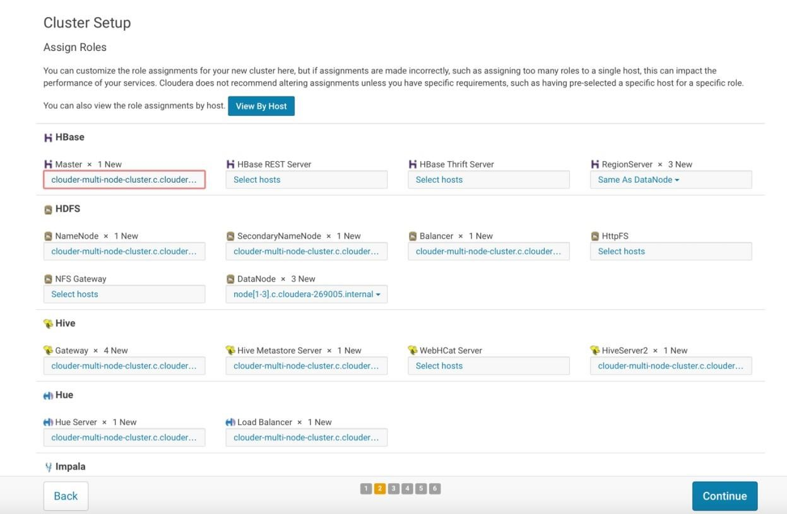

Click on Test Connection, see everything is okay. Click on Continue.

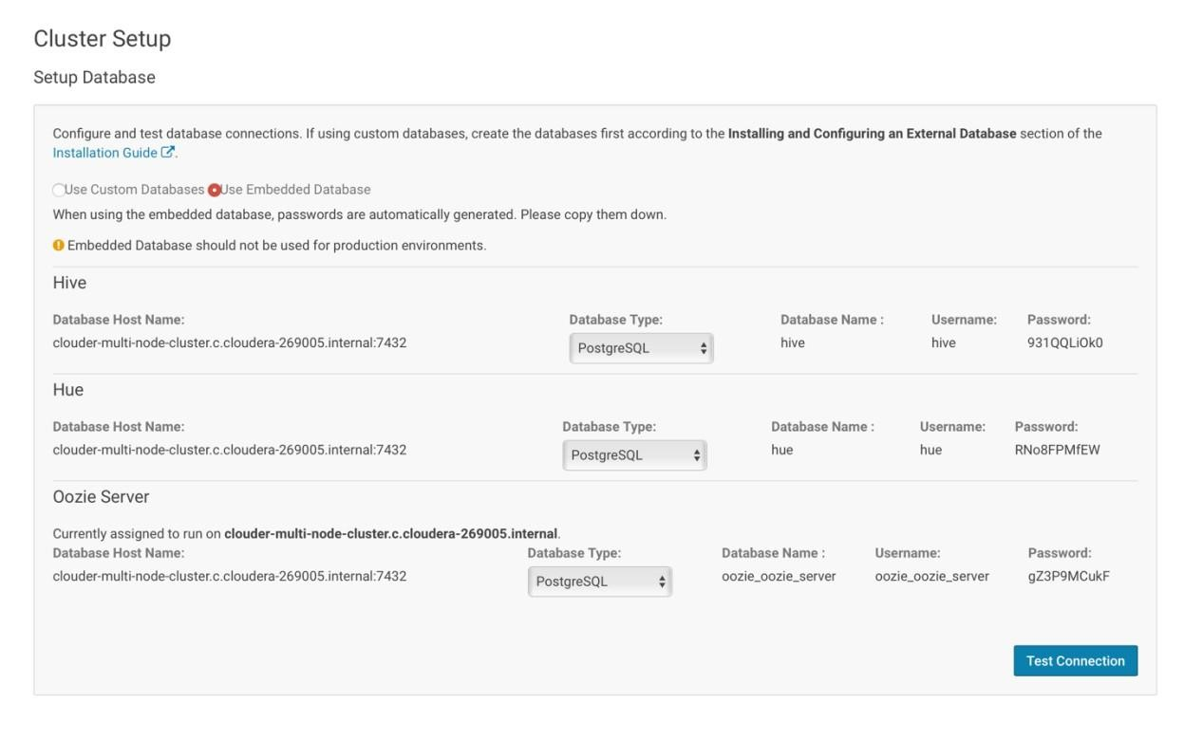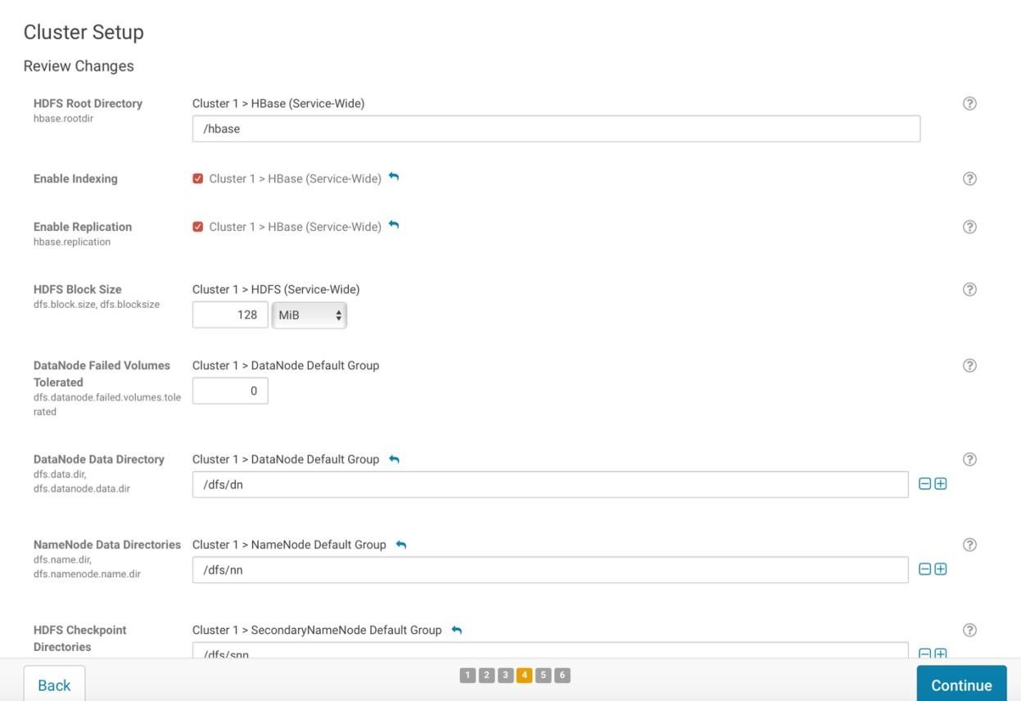

Again, wait for it…to finish executing. Just bear with me.

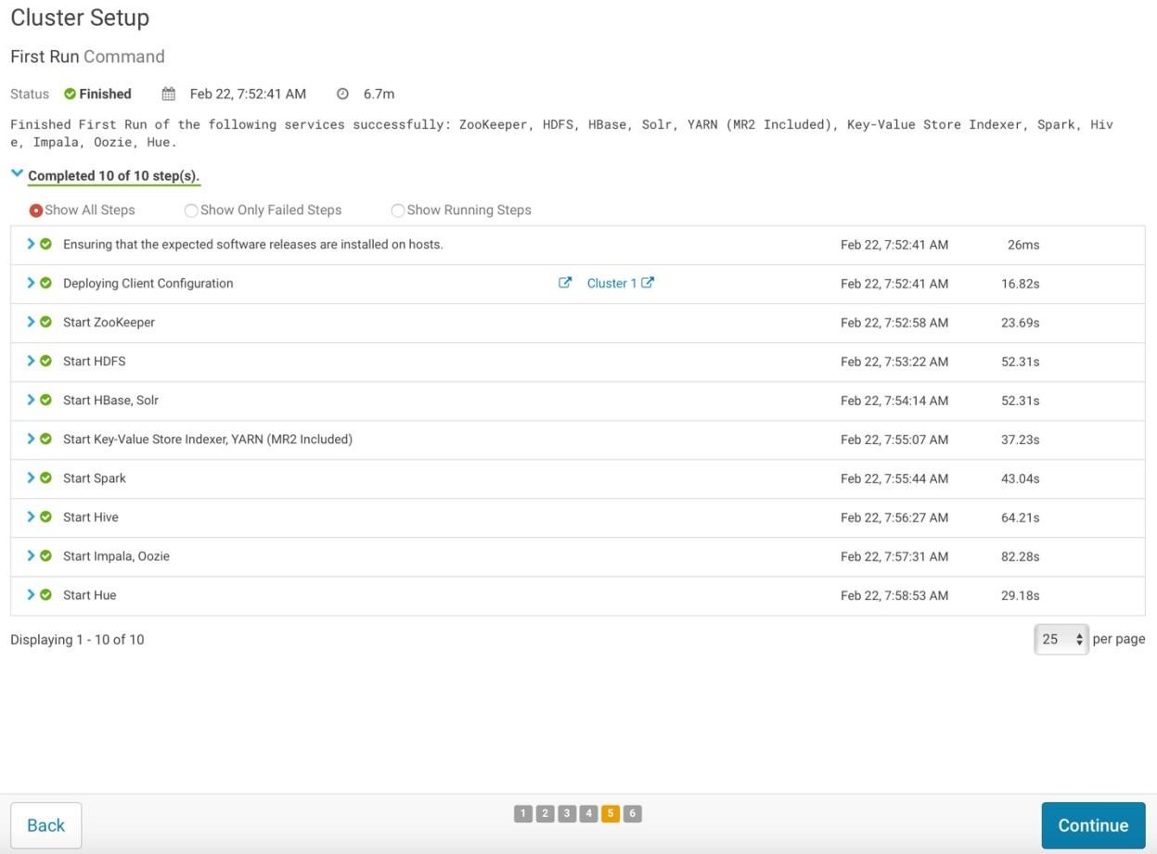

You made it!! Click on Finish and it will bring you to the web UI!

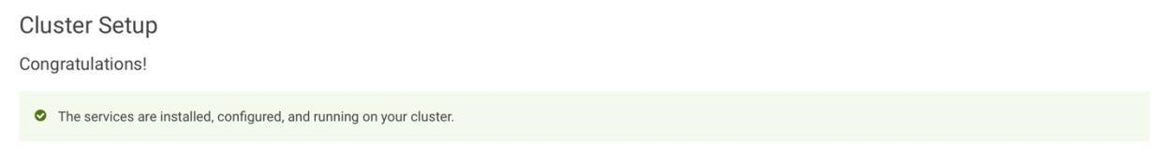

See the warning messages. Don’t worry, all you need to do is to restart Cloudera Manager and Cluster 1.

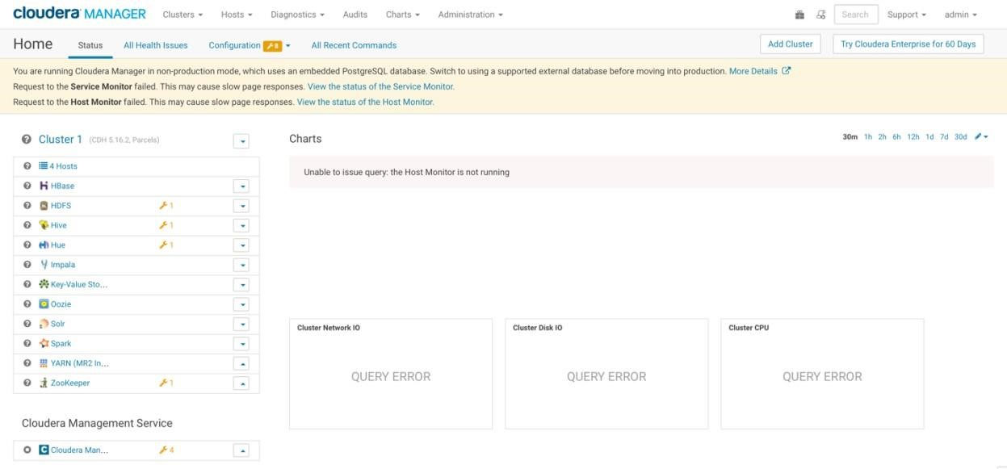

Go to port 8888. Set both username and password to cloudera.

**Note**: If **you failed to open Hue web UI** using your cloudera-multi-node-cluster’s external IP, try use other three nodes’ external IPs followed by 8888. Your Hue may be installed on other nodes. Another way to check where Hue was installed, click on Hue in Cloudera Manager and Go to Instances tab, you will be able to see the node in which your Hue is installed on.

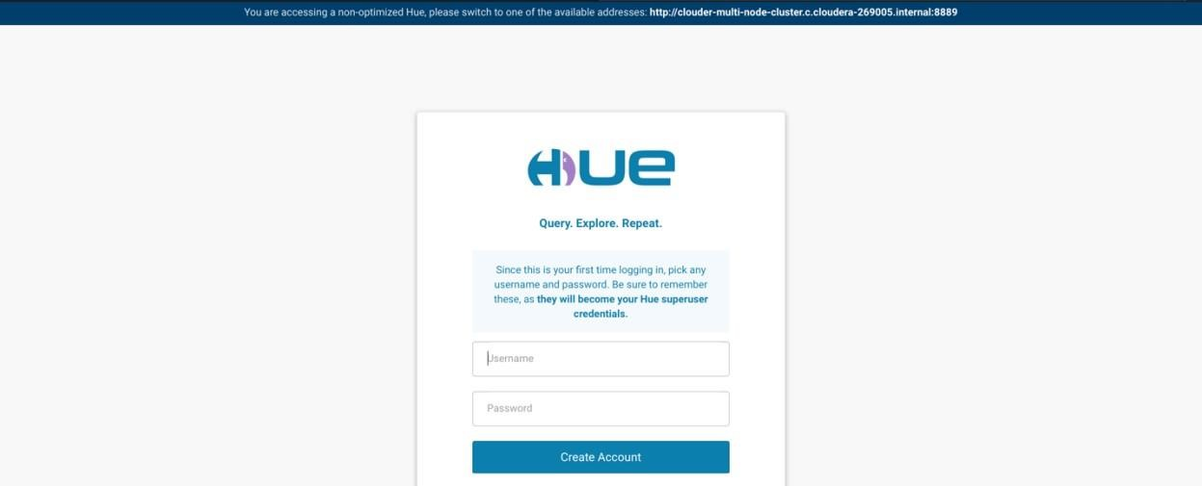

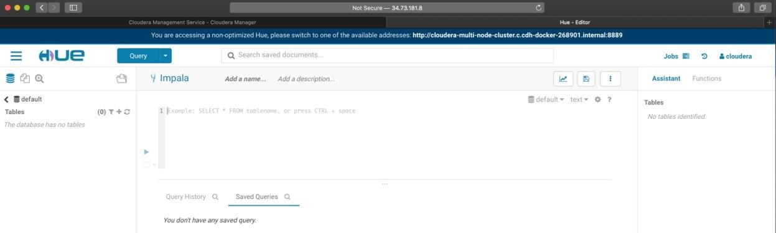

**Congratulations! You have successfully created instances and installed Cloudera services on them.**

**Attention: Please do not forget to stop your instances every time!!!!! Otherwise GCP will keep charging you.**

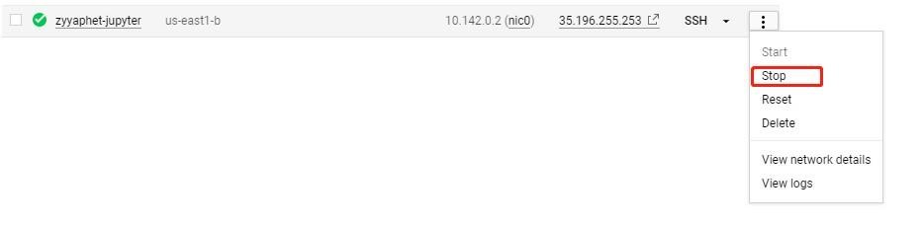

**Frequently Asked Questions**

# Authentication error when installing packages on nodes

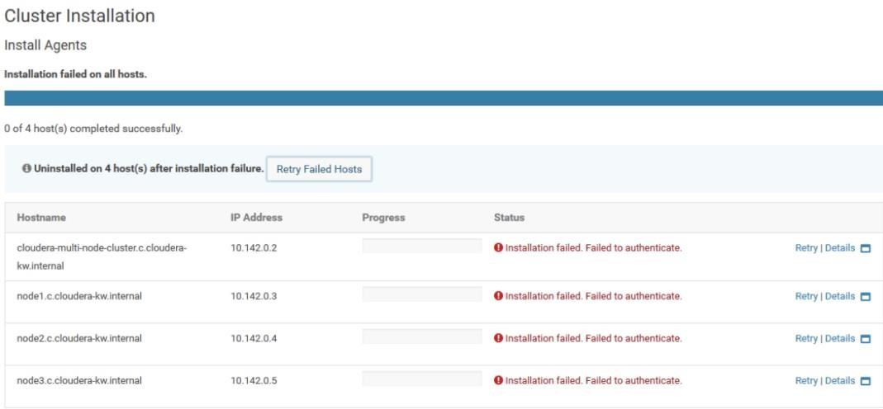

If you are experiencing authentication error, you probably did not configure your sshs_config files correctly. Please go back to the config files and check if you add or deleted “#” signs correctly. Do not forget to reboot your instances after you’re done with configuring the files and then click on the retry button on the installer UI.

# Health problem in Cloudera Manager

All you need to do it restart or start the services that has warning signs. Go to Clusters, click on Cloudera Manager/Cluster 1, and click on “Actions” tab. Click on start/restart.

# Failed to open Hue

If **you failed to open Hue web UI** using your cloudera-multi-node-cluster’s external IP, try use other three nodes’ external IPs followed by 8888. Your Hue may be installed on other nodes. Another way to check where Hue was installed, click on Hue in Cloudera Manager and Go to Instances tab, you will be able to see the node in which your Hue is installed on.